SHELLEY MANOR & HOLDENHURST PPG

Monday 5th December 2022

Present: Ken Newton, Chair
Dr Kayvan Bidad, Partner and PPG Lead
Emma Prince, Practice Business Manager
Sharon Ellison, Quality Lead
Ian Jones

Apologies : Tommy Thompson
Michael Filer
Anne Filer
Carole Corr
Michael Crich
Anne Marie Crosbie
Rob Wooton
Russell Jarvis (moved away but still wishes to be part of PPG – back soon)

Welcome and any apologies
Welcome to the PPG meeting. Apologies listed above.

Appointment system and data

Emma shared some really interesting data on appointments. We discussed the fact that it didn’t include the Duty Doctor data, so we actually see / respond to a lot more patients than the data suggests. (details below)

Split of F2F/telephone
86% of appointments at SMHMC are F2F; 9% telephone, 5% unknown
Proportion of F2F appointments in Dorset goes from 52% to 99%

By HCP
51% of appointments at SMHMC are with a GP; 44% with other HCPs; 5% unknown
Proportion of appointments with GP varies from 10% to 58% in Dorset

Number of appointments
We appear to offer the lowest number of appointments per 1000 patients, but we believe this is down to the way our Duty GP system operates. We have 2 GPs who work as Duty GPs, one on each site. They work from tasks (email messages in our clinical system), not appointments, so all the work they do would not show on this appointment data.

Limitations of the data
Does data not include lots of other forms of work – making referrals, test result actioning, visits, actioning hospital letters, signing and checking prescriptions, medication reviews, issuing Fit Notes, safeguarding processes, registrations, supporting and teaching – we are a Training practice
- 97 ‘two week wait’ referrals done in last month
- 353 patients registered last month – list size remains largely static
- 7104 medication issues in last month
- 671 medication reviews done in last month
- 4570 letters processed in last month
- 382 Fit Notes issues in last month
- 1712 test reports filed

Appointment numbers on system
w/c 7/11 2015
w/c 14/11 2073
w/c 21/11 2246
w/c 28/11 2071

Monthly Friends and Family questionnaire – Excellent feedback again last month from the Friends and Family questionnaire. Ian agreed that Shelley Manor has always given him and his family excellent treatment and deserves the good feedback.
Over 92% = Good or Very good! Less than 4% said Poor or Very poor.

1 = Very good
2 = Good
3 = Neither good nor bad / Neutral
4 = Poor
5 = Very poor
6 = Don’t know / No opinion
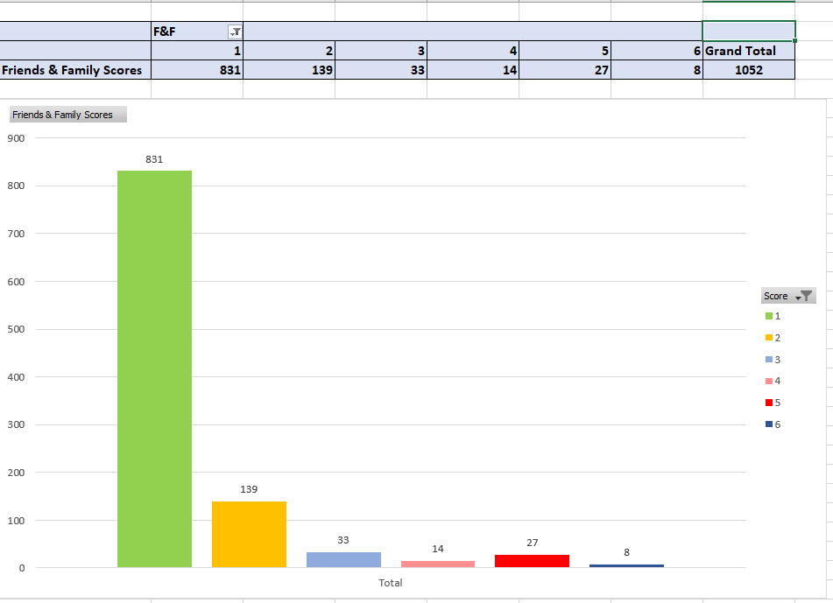

Practice Update
SM BEC Treatment Centre (1st floor – in the Private suite)

We are recruiting more services to be part of the treatment centre attached to Shelley Manor. We are still looking to recruit a Mental Health Practitioner but we have recently recruited two new Physiotherapists who are seeing patients with newly presenting musculoskeletal (MSK) problems, as a first point of contact instead of seeing a GP, this leaves more GP appointments available for other things. There are also ANP’s, Nurses, HCA’s and GP’s available there at various times, both during our usual opening times and later in the day (4pm to 8pm), all Surgeries in the Network have access to these appointments as well as Shelley Manor and Holdenhurst patients.
Recruitment/Staff changes – Another Care Co-ordinator (Sarah Bates) has now started to support the admin involved in Sharon’s department. We also have some new receptionists. We are still trying to recruit a new salaried GP, this has been difficult as nearly all Practices are recruiting GP’s and there are very few available.

Patient Volunteer Group needs more members / volunteers (not Practice Champions any more)
ACTION – Sharon has sent out messages to try and recruit more patient volunteers for the Patient Volunteers Group. We are also always recruiting for the PPG, including patients who cannot make the meetings but would like to receive information via the PPG distribution list. A few new members have been recruited for the PPG but they couldn’t make it this time.

Any other business:
Dr Bidad advised that a past valued member of the PPG had died and left £1,000 to Shelley Manor in his will to buy a piece of equipment with, in his memory. Dr Bidad advised he will ask the Partners and decide what will be purchased, to update next time.

Date of next meeting: 2.30 – 3.30pm Monday 6th March 2023

